**Scenarios of the Degree of Centrality and Density of the Networks of the Main Brazilian Airports between 2003 to 2020**

**Luiz Rodrigo Bonette**

Doutorando em Engenharia de Produção pela Universidade Paulista

E-mail: luiz.bonette@aluno.unip.br

**Fernanda Alves de Araújo**

Mestre em Engenharia de Produção pela Universidade Paulista

E-mail: fernanda.logistica@gmail.com

**João Gilberto Mendes dos Reis**

Doutor em Engenharia de Produção pela Universidade Paulista

Professor da Universidade Paulista

E-mail: joao.reis@docente.unip.br

**Paula Ferreira da Cruz Correia**

Doutoranda em Engenharia de Produção pela Universidade Paulista

E-mail: paulafecruz@gmail.com

**ABSTRACT**

The identification of air transport networks is relevant to the economic development of a city or region, through its passenger demands, and, in this case, there may be a difference between the formation of these networks in different periods and which are the main actors compared in a sample of seven airports. The aim of this study is to analyze the degree of centrality of the network of the seven largest Brazilian passenger airports. This sample is based on the analysis of network indicators for the collection and extraction of passenger data between destinations and airport origins by the National Civil Aviation Agency (ANAC). The Social Network Analysis (SNA) method was applied for the construction of networks through the application of @ Ucinet/Netdraw Version 6.716 software to understand the degree of centrality and the density of the network in the scenarios of 2003, 2007, 2015, 2018, and 2020. It was concluded that the conjuncture of the links and nodes within the scenarios of the hub-and-spoke airport networks of the flows is sustained, to a greater and lesser extent in the network, by an airport in the Brazilian midwestern region (Brasília) and two other airports in the southeastern region. For future contributions, the nine-month 2020 Covid-19 pandemic period was analyzed, bringing results such as reductions in the degrees of centrality and density of the network of these seven airports.

**Keywords.** Airports, Passengers, Hub-And-Spoke, SNA.

**RESUMO**

A identificação das redes de transporte aéreo é relevante para o desenvolvimento econômico de uma cidade ou região, por meio de suas demandas de passageiros, e, neste caso, pode haver uma diferença entre a formação dessas redes em diferentes períodos e quais são os principais atores comparados em uma amostra de sete aeroportos. O objetivo deste estudo foi analisar o grau de centralidade da malha dos sete maiores aeroportos brasileiros de passageiros. Esta amostra é baseada na análise de indicadores de rede para coleta e extração de dados de passageiros entre destinos e origens aeroportuárias pela Agência Nacional de Aviação Civil (ANAC). O método de Análise de Redes Sociais (SNA) foi aplicado para a construção de redes através da aplicação do software @ Ucinet / Netdraw Versão 6.716 para entender o grau de centralidade e a densidade da rede nos cenários de 2003, 2007, 2015, 2018, e 2020. Concluiu-se que a conjuntura dos elos e nós dentro dos cenários das redes *hub-and-spoke airport* nos fluxos é sustentada, em maior ou menor grau na rede, por um aeroporto da região centro-oeste brasileiro (Brasília) e outros dois aeroportos da região sudeste do Brasil. Para contribuições futuras o período pandêmico da Covid-19 de nove meses de 2020 foi analisado, trazendo resultados como as reduções nos graus de centralidade e densidade da rede destes sete aeroportos.

**Keywords.** Aeroportos, Passageiros, Hub-And-Spoke, SNA.

# INTRODUCTION

Hub-and-spoke is a system of air transportation in which local airports offer flights to a central airport where international or long-distance flights are available (O'Kelly & Bryan, 1998). Aerial networks imply the consolidation of traffic from a range of diverse origins directed to a range of diverse final destinations at large central airports (Button, 2002). Hub cities have development advantages for certain types of economic activities that reflect two points of distinction that share a similar profile. The first, the concentration of large passengers and cargo flow, and the second, the high degree of connectivity with other domestic points and international air networks (Bowen, 2000).

Analyzing the network built of the seven largest Brazilian airports, based on the statistical reports of passenger movement of the National Civil Aviation Agency - ANAC (2019), it is possible to have differences between the passenger network demonstrating its density and finding the measure of centrality in periods many different. The study aims to analyze the degree of centrality of the network of the seven-passenger airports through the SNA (Social Analysis Network) network method using the @ Ucinet / Netdraw software. The main actors in the simulated network were mapped and graphically constructed, with airports and cities valued for their movements data (passengers) and links (connections) in their flows in the national civil aviation market.

Air transport and distribution in their current networks are undergoing profound modifications and thus adapting to their aviation demands when analyzing the different annual scenarios, in this case, 2003, 2007, 2015, 2018, and 2020. The methodology deals with passenger movements between seven airports (Belo Horizonte - Confins, Brasília, Campinas, São Paulo - Guarulhos, São Paulo - Congonhas, Rio de Janeiro - Galeão, Rio de Janeiro - Santos Dumont) using the concept of centrality measure in networks of a degree of density (connectivity) of the network.

The discussion and results propose the visualization and comparison of the airport network proposed by scenarios and historical antecedents before the year of data collection. The conclusion offers the trends and possibilities of how this network can be configured in its links by factors such as concentration and connectivity of the actors, starting from the aviation data of passengers of origin and destination.

# THEORETICAL REFERENCE

**2.1 Hub-and-spoke**

Central airports consider indirect connections through their hub as an essential strategy (Veldhuis & Kroes, 2002). There is the problem of locating the arc of the hub, where a certain number of arcs are located in the hub (with reduced transport cost per unit) to satisfy a demand for travel between the specified origin-destination pairs (Campbell et al., 2003). The hub is a measure of centrality and nodes are the links in a hub-and-spoke network (Button, 2002).

Janic (2005) and Ball et al. (2006) point out that the vulnerability of the hub-and-spoke system uses several mitigation strategies proposed to postpone, cancel or forward the air transport system. There are three separate components for each hub-and-spoke flow, the collection (source node to hub node), transfer (hub node to hub node), and distribution (hub node to destination node) (Campbell et al., 2007). Hub network analysis focuses on combinations of models associating central hubs and economic objectives, central hubs, and service levels (Campbell, 1994).

The hub hierarchy must be analyzed by the flight frequency, hub accessibility, and passenger variables to help and define the layers of this hub hierarchy, influencing the connectivity index of the entire hub-and-spoke network (Ryerson & Kim, 2013). Cargo transportation is more complex than passenger transportation because the former involves more actors with processes. Therefore, it is more sophisticated and combining volumes, with varied priority services, with strategies for integrating and consolidating various itineraries in a network of transportation (Feng et al., 2015).

The hub accessibility criterion explores the position of the simulated networks without including small or regional airports and their impacts in terms of economic activity and competitive pressure on the hub-and-spoke network, therefore, it is necessary to analyze the hub behavior (Redondi et al., 2012).

The connectivity potential of airports, analyzed by connectivity indexes in their regions, is influenced by the demand and plays a key role in determining the role of airports in hub-and-spoke networks (Rodríguez-Deníz et al., 2013). The hub-and-spoke network uses the concept of “substitute hub” or “backup hub” within the design of the hub-and-spoke network for roundtrip flows parallel to the central hub flow (Yu et al., 2015). Mohri et al. (2018) consider the possibility of a direct conflict between no-hubs, together with the problem of determining the capacity of the nodes of a hub with a multiple network allocation model.

All possible allocation strategies, such as the extension for each allocation strategy, make it possible to model cases in which direct connections between no-hub nodes are allowed, in this case, testing and evaluating the performance of the proposed models (Taherkhani & Alumur, 2019).

**2.2 Hub-and-spoke network composition**

Route systems, by their nature and geographic scope, are based on route level data, relating airlines and airports to route structure, costs, and carrier performance (Bania et al., 1998). Six factors shape the design of integrating networks, such as the liberalization of the airline industry, the centrality of the market and intermediation, the ground transportation networks, competition among complementary aerial networks, the growth of transport networks, and the characteristics of aircraft (Bowen, 2012). The hub-and-spoke network is formed in building blocks of the quality approach by weighting connection levels, such as: the connection identification level, the connection quality level and the destination level (Burghouwt & Wit, 2005; Allroggen et al., 2015).

**Table 1 - Congestion considerations**

|  |  |
| --- | --- |
| Author | Factors that affect Hub congestion |
| (Fageda & Flores-Fillol, 2015) | Airline networks, network efficiency and airport congestion. |
| (Brueckner & Lin, 2016) | Concentration of flights, airlines, hub congestion, downtime cost, hub-and-spoke network, downtime cost. |
| (Lin & Yimin, 2017) | Price of hub congestion at the airport, investment in its capacity, use of a simple hub-and-spoke model with an emphasis on the hub airport as a profit maximizer. |
| (Mohri et al., 2018) | Hub location problem, congestion, hub capacity. |
| (Alkaabenh et al., 2019) | Hub-and-Spoke design network, Congestion, Economy of scale and non-linear systems. |

Source: Authors (2020).

# METHODOLOGY

For the applicability of this research, the Social Network Analysis (SNA) method was used through the techniques of centrality and density measurements with the @ Ucinet/Netdraw software (Borgatti, 2002; Borgatti et al., 2002).

We sought to explore the data from ANAC (2019) statistical reports with the annual databases in the periods of 2003, 2007, 2015, 2018, and nine months of the COVID19 pandemic period in 2020, resulting in the sample of seven airports analyzed (Belo Horizonte - Confins, Brasília, Campinas, São Paulo - Guarulhos, São Paulo - Congonhas, Rio de Janeiro - Galeão, Rio de Janeiro - Santos Dumont).

The methodological process had the following stages: (1) the treatment of data by electronic spreadsheets and the construction of the relational matrix of numerical balances and 0; 1 per year, (2) the application of the SNA method with the generation of the graph and diagram and (3) the simulations of the measurement tables of the degree of centrality and density to assess the behavior of the SNA in this network (Hanneman, 2001; Hanneman & Riddle, 2005; Scott, 2000; Wasserman & Faust, 1994).

**Table 2 - The coding of airport acronyms by the International Civil Aviation Organization. (ICAO)**

|  |  |  |  |
| --- | --- | --- | --- |
| Nº | ICAO | Airport | Localização |
| 1 | SBBR | International Airport of Brasília (Presidente Juscelino Kubitschek) | Brasília |
| 2 | SBCF | International Airport of Belo Horizonte-Confins (Tancredo Neves) | Confins |
| 3 | SBGL | International Airport of Rio de Janeiro (Tom Jobim/Aeroporto do Galeão) | Rio de Janeiro |
| 4 | SBGR | International Airport of São Paulo/Guarulhos (André Franco Montoro) | Guarulhos |
| 5 | SBKP | International Airport of Campinas (Viracopos-Campinas) | Campinas |
| 6 | SBRJ | International Airport of Rio de Janeiro (Santos Dumont) | Rio de Janeiro |
| 7 | SBSP | International Airport of São Paulo/Congonhas (Deputado Freitas Nobre) | São Paulo |

Source: ICAO (2020)

# RESULT AND DISCUSSION

The networks of the seven airports analyzed by the SNA method in the periods of 2003, 2007, 2015, 2018, and 2020 are of the types of characterized networks and classified as distributed and symmetrical, being from the direction of nodes to the bidirectional links structured in a relational matrix. It takes into account the following historical background necessary for extracting ANAC's statistical reports between the years 2003, 2007, 2015, 2018, and 2020.

**Table 3 - The historical background of the periods related to the analysis of the five networks.**

|  |  |
| --- | --- |
| Year | Historical background |
| 2003 | In 2002 there was the third phase of the deregulation plan for the Brazilian airline industry. |
| 2007 | In 2006 there was the phenomenon of "Air Blackout". |
| 2015 | In 2014, the "Political Crisis in Brazil" begins, which negatively affects the country's economic indicators. |
| 2018 | Economic Recession extends from 2014 to 2018 associated with the country's election year. |
| 2020 | COVID-19 Pandemic Period |

Source: Authors (2020).

The analysis criteria of the SNA method refer to the following aspects for the next figures 1, 2, 3, 4, and 5:

* Outdegree (nOutdeg): Output degree (origin/destination).
* Indegree (nIndeg): Input degree (destination/origin).
* Centralization: It is a special condition in which an actor plays a central role by being connected to all nodes, which need to pass through the central node to connect, which can be Centralization Outdegree (Out-Ce) or Centralization Indegree (In- Ce).
* Density: Shows whether the network has high or low connectivity between the number of existing relationships with the possible relationships.
* Kcore: Possibility of subnetworks supported by actors who mediate these connections.

**Table 4 - The 2003 airport database**

|  |  |  |  |  |  |  |  |
| --- | --- | --- | --- | --- | --- | --- | --- |
| ICAO | SBBR | SBCF | SBGL | SBGR | SBKP | SBRJ | SBSP |
| SBBR | 0 | 5959 | 99301 | 116221 | 60770 | 344111 | 646175 |
| SBCF | 2896 | 0 | 11 | 100484 | 210 | 890 | 8392 |
| SBGL | 3164 | 0 | 0 | 278748 | 7043 | 0 | 71197 |
| SBGR | 108674 | 90488 | 273296 | 0 | 4617 | 1491 | 138 |
| SBKP | 61200 | 331 | 5767 | 7789 | 0 | 80400 | 841 |
| SBRJ | 349112 | 1245 | 37 | 3390 | 80142 | 0 | 1521516 |
| SBSP | 651773 | 3351 | 72922 | 507 | 1450 | 1556832 | 0 |

Source: Authors (2020).

**Figure 1 - The network scenario in 2003 after the third phase of the deregulation plan for the Brazilian airline industry in 2002**

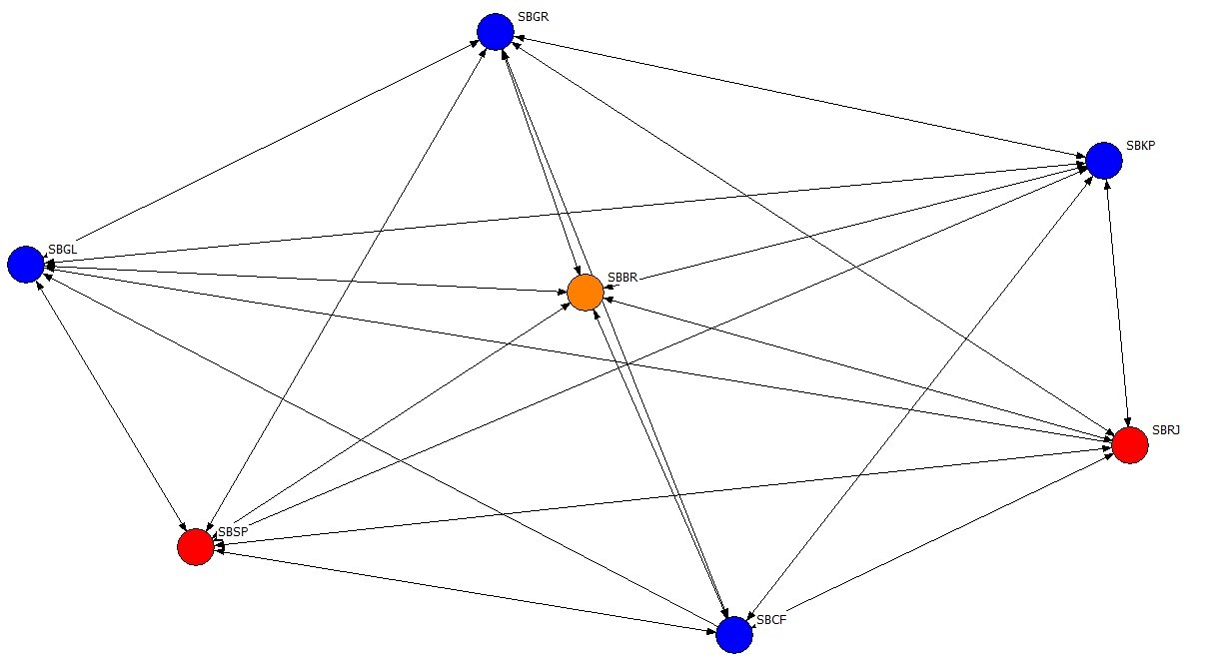

Source: Authors (2020).

The network simulation revealed the following behavior of the seven airports for the 2003 scenario: SBSP airports have 24.50%, and SBRJ has 24.10% of nOutdeg, whereas in nIndeg SBSP has 24.10% and SBRJ has 21.20 % demonstrating that they are dominant airports in this network and 2003's scenario. Taking into account that SBBR is an intermediary in the dominance of origins and destinations with 13.60% nOutdeg and 12.60% nIndeg. The other four airports have lower grades in the analysis scale, such as SBGR (nOutdeg of 5.10% and nIndeg of 5.40%), SBGL (nOutdeg of 3.90% and nIndeg of 4.80%), SBKP (nOutdeg of 1.70% and nIndeg of 1.70%); SBCF (nOutdeg of 1.20% and nIndeg of 1.10%). On the centralization degree as a basis on the central axis of the network, 16.75% of Out-Ce and In-Ce were 16.26%.

Regarding the network Density, there is a 95.20% degree of connections to the links of all possible interactions, demonstrating high network connectivity in 2003.

**Table 5 - The 2007 airport database**

|  |  |  |  |  |  |  |  |
| --- | --- | --- | --- | --- | --- | --- | --- |
| ICAO | SBBR | SBCF | SBGL | SBGR | SBKP | SBRJ | SBSP |
| SBBR | 0 | 291331 | 605234 | 276826 | 101936 | 0 | 680771 |
| SBCF | 309911 | 0 | 373097 | 271392 | 86928 | 2 | 507016 |
| SBGL | 602084 | 373906 | 0 | 429416 | 133151 | 0 | 286567 |
| SBGR | 291963 | 240913 | 410552 | 0 | 3770 | 5439 | 25 |
| SBKP | 109012 | 78272 | 140906 | 3403 | 0 | 0 | 336 |
| SBRJ | 0 | 0 | 4 | 23892 | 1869 | 0 | 1569662 |
| SBSP | 702490 | 558896 | 327787 | 508 | 1456 | 1578412 | 0 |

Source: Authors (2020).

**Figure 2 - The network scenario in 2007, after the Air Blackout phenomenon, in 2006**

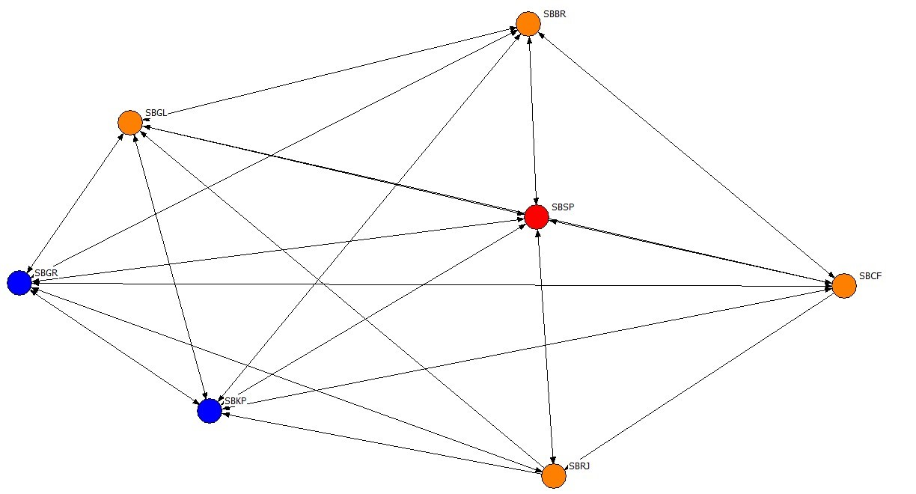

Source: Authors (2020).

The network simulation revealed the following behavior of the seven airports for the 2007 scenario: the SBSP airport had 33.50% nOutdeg, while in nIndeg SBSP it had 31.10% demonstrating that it was a dominant airport in this network and 2007's scenario. Taking into account a group of four intermediate airports in dominance of origins and destinations, namely SBBR (nOutdeg of 20.70% and nIndeg of 21.30%), SBGL (nOutdeg of 19.30% and nIndeg of 16.60%), SBRJ (nOutdeg of 16.80% and nIndeg of 16.70%), SBCF (nOutdeg of 16.30% and nIndeg of 16.30%). The other two airports have lower grades in the analysis scale, such as SBGR (nOutdeg of 10.01% and nIndeg of 10.60%), SBKP (nOutdeg of 3.50% and nIndeg of 3.50%). Regarding the degree of centralization as a basis in the central axis of the network, there was 19.02% of Out-Ce and In-Ce 17.48%, which increased compared to 2003's scenario.

Regarding the network Density, 88.10% of connections were made to the links of all possible interactions, showing high network connectivity in 2007. However, there was a drop compared to 2003's scenario.

**Table 6 - The 2015 airport database**

|  |  |  |  |  |  |  |  |
| --- | --- | --- | --- | --- | --- | --- | --- |
| ICAO | SBBR | SBCF | SBGL | SBGR | SBKP | SBRJ | SBSP |
| SBBR | 0 | 18901 | 369870 | 622498 | 28251 | 650870 | 1140985 |
| SBCF | 424812 | 0 | 206583 | 466274 | 45947 | 355085 | 806117 |
| SBGL | 362908 | 187245 | 0 | 720229 | 155971 | 0 | 464608 |
| SBGR | 597842 | 501220 | 699905 | 0 | 28 | 321016 | 0 |
| SBKP | 280004 | 47124 | 140636 | 1154 | 0 | 166120 | 122 |
| SBRJ | 641741 | 356483 | 373 | 342039 | 171376 | 0 | 2067869 |
| SBSP | 1139621 | 798975 | 504270 | 1211 | 129 | 2052786 | 0 |

Source: Authors (2020).

**Figure 3 - The 2015 network scenario a year after the political crisis in 2014**



Source: Authors (2020).

The network simulation revealed the following behavior of the seven airports for the 2015 scenario. The SBSP airport had 36.20% nOutdeg, whereas in nIndeg, SBSP it had 36.10% demonstrating that it was a dominant airport in this network and 2015's scenario. Taking into account a group of five intermediate airports in dominance of origins and destinations, being SBRJ (nOutdeg of 28.90% and nIndeg of 28.60%), SBBR (nOutdeg of 22.80% and nIndeg of 27.80% ), SBCF (nOutdeg of 18.60% and nIndeg of 15.40%), SBGR (nOutdeg of 17.10% and nIndeg of 17.40%); SBGL (nOutdeg of 15.20% and nIndeg of 15.50%). Only one airport has a lower grade on the analysis scale, being SBKP (nOutdeg of 5.10% and nIndeg of 3.20%).

Regarding the degree of centralization as a base in the central axis of the network, there was 18.30% of Out-Ce and In-Ce 18.13%, which increased compared to the 2003's scenario.

Regarding the network Density, the degree of 95.20% of connections to the links of all possible interactions was demonstrated, showing high network connectivity in 2007. This value of the network Density returns to levels close to the 2003 scenario.

**Table 7 - The 2018 airport database**

|  |  |  |  |  |  |  |  |
| --- | --- | --- | --- | --- | --- | --- | --- |
| ICAO | SBBR | SBCF | SBGL | SBGR | SBKP | SBRJ | SBSP |
| SBBR | 0 | 439551 | 361096 | 718580 | 288645 | 607168 | 1052521 |
| SBCF | 436596 | 0 | 182783 | 835968 | 299507 | 397770 | 906480 |
| SBGL | 365028 | 174253 | 0 | 675006 | 192074 | 0 | 403794 |
| SBGR | 720522 | 821393 | 671816 | 0 | 155 | 352974 | 0 |
| SBKP | 282078 | 304154 | 192498 | 433 | 0 | 249917 | 84 |
| SBRJ | 569450 | 406777 | 360 | 362525 | 250901 | 0 | 2164599 |
| SBSP | 1065134 | 894008 | 402231 | 1001 | 425 | 2147752 | 0 |

Source: Authors (2020).

**Figure 4 - The 2018 network scenario with Economic Recession and Elections**



Source: Authors (2020).

The network simulation revealed the following behavior of the seven airports for the 2018 scenario. The SBSP airport had 34.70% of nOutdeg, whereas, in nIndeg, SBSP had 34.90% demonstrating that it was a dominant airport in this network and 2018's scenario. Taking into account a group of four intermediate airports in dominance of origins and destinations, being SBRJ (nOutdeg of 28.90% and nIndeg of 28.90%), SBBR (nOutdeg of 26.70% and nIndeg of 26.50%), SBCF (nOutdeg of 23.60% and nIndeg of 23.40%), SBGR (nOutdeg of 19.80% and nIndeg of 20.00%). The other two airports have lower degrees in the analysis scale, such as SBGL (nOutdeg of 13.90% and nIndeg of 13.90%), SBKP (nOutdeg of 7.90% and nIndeg of 7.90%).

Regarding the degree of centralization as a basis in the central axis of the network, there was 14.60% of Out-Ce and In-Ce 14.70%. A decrease if compared to the scenarios of 2003, 2007, and 2015.

Concerning the network Density, the degree of 95.20% of connections to the links of all possible interactions was demonstrating high network connectivity in 2018.

When simulating Kcore in 2003, 2007, 2015, and 2018 scenarios, no subnet creation was provenOn the other hand, a direct connection was pointed out to the 7 airports without intermediaries in their relations of origins and destinations.

**4.1 Contributions to the Pandemic Period (Covid-19)**

This subsection was created due to the relevance of the pandemic period, in this part of the research, the period of 9 months of 2020 was approached in contrast to the previously analyzed periods of 2003, 2007, 2015, and 2018 scenarios that were collected in 12 months. Due to the Covid-19 Pandemic and its impacts on the airport sector, the urgency of the contributions makes the research to be approached in this context, of the 2020 scenario.

**Table 8 - The 2020 airport database**

|  |  |  |  |  |  |  |  |
| --- | --- | --- | --- | --- | --- | --- | --- |
| ICAO | SBBR | SBCF | SBGL | SBGR | SBKP | SBRJ | SBSP |
| SBBR | 0 | 126981 | 87464 | 247468 | 124617 | 215933 | 225301 |
| SBCF | 124839 | 0 | 38089 | 250807 | 1370771 | 115541 | 223846 |
| SBGL | 94873 | 41252 | 0 | 193531 | 52939 | 0 | 50408 |
| SBGR | 250046 | 231662 | 187312 | 0 | 0 | 18042 | 0 |
| SBKP | 152280 | 142441 | 47858 | 10 | 0 | 125692 | 32 |
| SBRJ | 239721 | 116521 | 272 | 192725 | 132154 | 0 | 550324 |
| SBSP | 221451 | 223600 | 50753 | 336 | 0 | 511444 | 0 |

Source: Authors (2020).

**Figure 5 - The 2020’s network scenario during a period of 9 months of the Covid-19 Pandemic**



Source: Authors (2020).

The network simulation revealed the following behavior of the seven airports for the 2020 scenario. Five airports divided the network as main players in this scenario, with no dominant airports, namely: SBRJ (nOutdeg of 15.00% and nIndeg of 12, 00%), SBBR (nOutdeg of 12.50% and nIndeg of 13.20%), SBSP (nOutdeg of 12.30% and nIndeg of 12.80%), SBCF (nOutdeg of 25.80% and nIndeg of 10,70%), SBGR (nOutdeg of 8.40% and nIndeg of 10.80%). In this scenario, there was no airport with an intermediate function to the network of origins and destinations. The other two airports have lower degrees in the analysis scale, such as SBKP (nOutdeg of 5.70% and nIndeg of 20.40%) and SBGL (nOutdeg of 5.30% and nIndeg of 5.00%).

**Table 9 - The network performance based on the proposed scenarios**

|  |  |  |  |  |
| --- | --- | --- | --- | --- |
| Scenarios | Months | Out-Ce | In-Ce | Density |
| 2003 | 12 | 16,75 | 16,26 | 95,2 |
| 2007 | 12 | 19,02 | 17,48 | 88,1 |
| 2015 | 12 | 18,3 | 18,13 | 95,2 |
| 2018 | 12 | 14,6 | 14,7 | 95,2 |
| 2020 | 9 | 15,98 | 9,69 | 90,5 |

Source: Authors (2020).

Regarding the degree of centralization as a basis in the central axis of the network, there was 15.98% of Out-Ce and In-Ce 9.69%, a drop compared to the scenarios of 2003, 2007, 2015, and 2018. About the network Density, there is a degree of 90.50% of connections to the links of all possible interactions, demonstrating high network connectivity in 2020, compared to previous scenarios of 2003, 2015, and 2018.

# CONCLUSION

The airports of Brasília (SBBR), São Paulo (SBSP), and Rio de Janeiro (SBRJ) have historically supported the network, generating its high connectivity. Over the period of the 18 years analyzed, Brasília airport has established itself as an actor with continuous and expressive growth in these networks. There is a high degree of connectivity and competitiveness among the largest Brazilian passenger airports in the scenarios of 2003, 2007, 2015, and 2018. In the 2020 scenario, it is possible to note that the pandemic period generated a significant drop in the degree of centrality and density of the network. In this case, there was a decentralization of the density flow from one airport (2003, 2007, 2015, and 2018 scenarios) to five airports in the 2020 scenario to support the network.

For future research, it is interesting to explore non-hub networks, reserve hub networks, and international cargo hubs as part of mitigating the effects of congestion hubs and for mapping and creating contingency plans for the Brazilian airport system.

# ACKNOWLEDGEMENT

This study was financed in part by the Coordenação de Aperfeiçoamento de Pessoal de Nível Superior - Brasil (CAPES) - Finance Code 001.

# REFERENCES

Alkaabneh, F., Diabat, A., & Elhedhli. (2019). A Lagrangian heuristic and GRASP for the hub-and-spoke network system with economies-of-scale and congestion. Transportation Research Part C, 102, 249–273.

Allroggen, F., Wittman, M. D., & Malina, R. (2015). How air transport connects the world – A new metric of air connectivity and its evolution between 1990 and2012. Transportation Research Part E, 80, 184-201. 2015.

Agência Nacional de Aviação Civil (ANAC). (2019). Base de dados completa. Dados Estatísticos*. Base de dados subdivida por ano 2000, 2009, 2015; 2018. Passageiros (Origem/Destino), Aeronaves (Pousos/Decolagens).

Ball, M., Barnhart, C., Nemhauser, G., & Odoni, A. (2006). Air transportation: irregular operations and control. In: Handbooks of Operations Research and Management, North-Holland.

Borgatti, S. P. (2002). NetDraw. Graph Visualization Software. Harvard: Analytic Technologies.

Borgatti, S. P., Everett. M.G., & Freeman, L. C. (2002). Ucinet for Windows Software for Social Network Analysis.

Brueckner, J. K., & Lin, M. H. (2016). Convenient flight connections vs. airport congestion: Modeling the ‘rolling hub’. International Journal of Industrial Organization, 48, 118–142.

Burghouwt, G., & Wit, J. (2005). Temporal Configurations of European Airline. Journal of Air Transport Management, 11(3), 185-198.

Button, K. (2002). "Debunking some common myths about airport hubs. "Journal of Air Transport Management, 8(3), 177- 202.

Campbell, J. F. (1994). Integer programming formulations of discrete hub location problems. European Journal of Operational Research, 72, 387–405.

Campbell, F. J., Stiehr, G., Ernst, A. T., & Krishnamoorthy, M. (2003). Solving hub arc location problems on a cluster of workstations. Parallel Computing, 29, 555-557.

Campbell, A. M., Lowe, T. J., & Zhang, L. (2007). The p-hub center allocation problem. European Journal of Operational Research, 176, 819-821, 834.

Fageda, X., & Flores-Fillol, R. (2017). A note on optimal airline networks under airport congestion. Economics Letters, 128, 90–94.

Feng, B., Li, Y., & Shen, Z. J. (2015). Air cargo operations: Literature review and comparison with pratices. Transportation Research Part C, 56, 263-280.

Hanneman, R. A. (2001). Introducción a los Métodos de Análisis de Redes Sociales. Departamento de Sociologia de la Universidade de Califórnia, Riverside, US, 150.

Hanneman, R. A., & Riddle, N. (2005). Introduction to SOCIAL Network Methods. Riverdise, CA: University of California, Riverside.

International Civil Aviation Organization - ICAO. (2020). Retrieved from <https://www.icao.int/Pages/default.aspx>

Janic, M. (2005). Modeling the large-scale disruption of an airline network. Journal Transport Engineer, 131, 249–260.

Lin, M. H., & Yimin, Z. (2017). Hub-airport congestion pricing and capacity investment. Transportation Research Part B: Methodological, 101, 89-106.

Mohri, S. S., Karimi, H., Kordani, A. A., & Nasrollahi, M. (2018). Airline hub-and spoke network design based on airport capacity envelope curve: A practical view. Computers & Industrial Engineering, 125, 375-393.

O'Kelly, M. E., & Bryan, D. L. B. (1998). "Hub location with flow economies of scale". Transportation Research B, 32(8), 608.

Ryerson, M. S., Kim, & H. (2013). Integrating airline operational practices into passenger airline hub deﬁnition. Journal of Transport Geography, 31, 84-63.

Rodríguez-Déniz, H., Suau-Sanchez, P., & Voltes-Dorta, A. (2013). Classifying airports according to their hub dimensions: an application to the US domestic network. Journal of Transport Geography, 33, 188-195.

Scott, J. (2000). Social Network Analysis. A handbook. New York. SAGE Publications Ltda, 2 edition.

Taherkhani, G., & Alumur, S. A. (2019). Profit maximizing hub location problems. Omega, 86, 1–15.

Veldhuis, J., & Kroes, E. K. (2002). Dynamics in relative network performance of the main European hub airports. European Transport Conference, Cambridge.

Yu, A., Yu, Z., & Bo, Z. (2015). The reliable hub-and-spoke design problem: Models and algorithms. Transportation Research Part B, 77, 103-122.

Wasserman, S., & Faust, K. (1994). Social Network Analysis: Methods and Applications. 1. ed. Cambridge: Cambridge University Press.